Lab Exercise 1: Tools of the Trade

zid: z5228006 name: MINGLANG XIE

# Exercise 1: nslookup

1. The IP address of the website [www.koala.com.au](http://www.koala.com.au):

* 129.94.242.2#53
* 172.67.219.46
* 104.18.60.21
* 104.18.61.21

In my opinion, website may be replicated on multiple servers, with each server running on a different end system, and each having a different IP address. This allow for load balancing, and website replies to the requests with one of the listed Ips and the client thus can connect to the website. However, the IP address not always the same, so the load isn’t concentrated always on the same server.

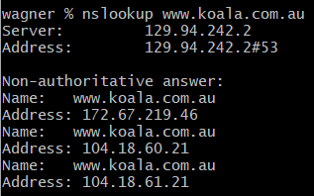

2. The name of the IP address 127.0.0.1 is “the loopback address/localhost”. The address is used to establish an IP connection to the same machine or computer being used by the end-user. The localhost refers to the internal interface used by the machine to send a packet to itself. TCP/IP send information locally but not on the network, it’s always used for testing purpose.

#### 

#### Exercise 2: Use ping to test host reachability

|  |  |  |
| --- | --- | --- |
| host | reachable by ping | Reachable from the Web |
| www.unsw.edu.au | Yes | Yes |
| www.getfittest.com.au | No | No |
| www.mit.edu | Yes | Yes |
| www.intel.com.au | Yes | Yes |
| www.tpg.com.au | Yes | Yes |
| www.hola.hp | No | No |
| www.amazon.com | Yes | Yes |
| www.tsinghua.edu.cn | Yes | Yes |
| www.kremlin.ru | No | Yes |
| 8.8.8.8 | Yes | No |

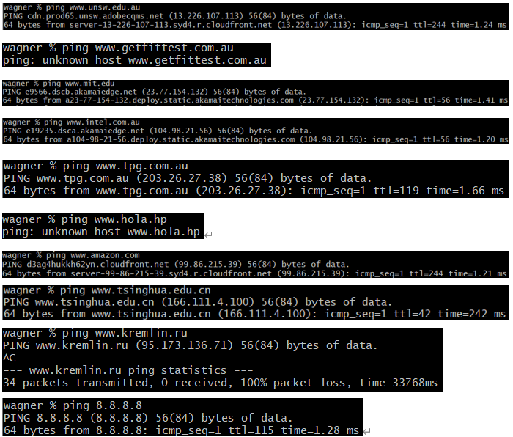

[www.getfittest.com.au](http://www.getfittest.com.au) and [www.hola.hp](http://www.hola.hp) are not reachable by ping and the Web browser, thus these websites does not exist.

[www.kremlin.ru](http://www.kremlin.ru) was not reachable by using ping, but it is reachable from the Web browser, this is because the organizations disable their network from replying to ICMP echo request packets which are used by ping. It’s always used because of security measure.

#### Exercise 3: Use traceroute to understand network topology

#### There are 21 routers between my workstation and [www.columbia.edu](http://www.columbia.edu) (22 hops, which the last hop we have reached the webserver), there are 4 routers along the path are part of the UNSW network. Between et-1-3-0.pe1.sxt.bkvl.nsw.aarnet.net.au (113.197.15.149) and et-0-0-0.pe1.a.hnl.aarnet.net.au (113.197.15.99), the round-trip times from my machine to the routers change from 1.9ms to 95.1ms. which means it packets cross the Pacific Ocean. However, according to my research of the IP address, the router address change from Australia to America is between et-2-1-0.bdr1.a.sea.aarnet.net.au (113.197.15.201) and abilene-1-lo-jmb-706.sttlwa.pacificwave.net (207.231.240.8), because these are very likely part of AARNET PoP (Point of Presence) that are physically located in Honolulu and Seattle (hostnames have “hnl” and “sea”). Therefore, between et-1-3-0.pe1.sxt.bkvl.nsw.aarnet.net.au (113.197.15.149) and et-0-0-0.pe1.a.hnl.aarnet.net.au (113.197.15.99) the address crosses the Pacific Ocean physically.

#### There are 5 hops are identical on all 3 paths, at the sixth router IP address 138.44.5.0 the paths from my machine to these three destinations diverge. The sixth router belongs to the AARNET network.

#### No, the number of hops on each path is not proportional to the physical distance. From Sydney to Tokyo is closer to from Sydney to LA, but from Sydney to Tokyo takes about 15 hops while from Sydney to LA also takes 15 hops.

#### The IP address of my machine is 129.94.242.251, the IP address of [www.speedtest.com.sg](http://www.speedtest.com.sg) is 202.150.221.170

#### Traceroute from my machine to [www.speedtest.com.sg](http://www.speedtest.com.sg):

#### Traceroute from [www.speedtest.com.sg](http://www.speedtest.com.sg) to my machine:

#### The path from my machine to speedtest.com.sg go through routers in [Singapore](http://www.baidu.com/link?url=zUrpMjVm24W1tID1uTWLVny5hd0-rjCyEgaks7Om8E7S56Vp8imZNGNaVsnLk9B0pQGMv2tPUpprQ0-ZdS8vVjm1KXi8o5U2M-mzqR5qV5q) (103.16.102.67). However, the path from speedtest.com.sg to my machine go through LA (203.208.171.117).

#### There is a same router but with different IP address, speedtest.com.sg to my machine: 138.44.5.1, my machine to speedtest.com.sg: 138.44.5.0 both IP address belongs to the same route but have been allocated to a different interface.

#### The IP address of my machine is 129.94.242.251, the IP address of [www.telstra.net](http://www.telstra.net) is 203.50.5.178

#### Traceroute from my machine to [www.telstra.net](http://www.telstra.net):

#### Traceroute from [www.telstra.net](http://www.telstra.net) to my machine:

#### It is obvious that routers on the internet do not need to be symmetric. This is helpful for a better load balance, so entity would like to have separate routers to handle ingoing and outgoing connections. However, even forward, and reverse path cross the same router, it is possible that different IP address are observed, we observe different IP address in the two paths (Telstra to my machine: 113.197.15.13, my machine to Telstra: 113.197.15.12). The traceroute output are the names of the router interfaces, but not the name of routers. Thus, both IP address belongs to the same route but have been allocated to a different interface. For example, Telstra to my machine: 138.44.5.1, my machine to Telstra: 138.44.5.0.

#### Exercise 4: Use ping to gain insights into network performance

#### 1. Physical distance from UNSW to each location:

#### Brisbane: 737km, Kuala Lumpur: 6620km, Berlin: 16100km

#### Let us assume that the packet moves at the speed of light, $3×{10}^{8} m/s$.The shortest possible time from UNSW to each location:

#### Brisbane: 2.5ms, Kuala Lumpur: 22.1ms, Berlin: 53.7ms

#### Minimum RTT (for 50 bytes packets) to each location (from the corresponding *avg.txt file):

#### Brisbane: 16.983ms, Kuala Lumpur: 100.637ms, Berlin: 281.910ms

#### Thus, the ratios of the minimum RTT to the minimum propagation delay for each location:

#### Brisbane: 6.8, Kuala Lumpur: 4.5, Berlin: 5.2

#### The following plot show the ratio as a function of distance:

#### There are lots of reasons why the y-axis values are greater than 2:

#### The speed of light does not consider for the transmission delays.

#### Packets do not travel as the full speed of light

#### Packets may traverse low bandwidth links such that it takes considerably extra time for the full packet to transit the link.

#### 2. The delay of the destination vary over time, because the speed of delay might treat as the speed of light, it is vary when going through different objects.

#### 3. The website for [www.epfl.ch](http://www.epfl.ch) is not hosted in Switzerland, I confirm this from ping, traceroute, and research on the website. It is hosted in [www.epfl.ch.cdn.cloudflare.net](http://www.epfl.ch.cdn.cloudflare.net) which is 12 hops away from UNSW.

#### 4.

#### The propagation delay does not depend on the packet size.

#### The transmission delay is almost proportional to the packet size.

#### The processing delay can depend on the packet size, but less dependence than the transmission delay.

#### The queuing delay only depends on the congestion in the network.